Installation
G U I D E

Prepared by: Ryan Ashwin & Christopher

Installation Guide

Introduction

Welcome to the comprehensive installation guide for our project. This guide explains how to install and run the AI-powered SOC Assistant for NetWitness Log and Incident Analysis developed for our Final Year Project (SOI-2025-2520-0043).

The system is built using Python and Streamlit and integrates Large Language Models; in our case, AINTELLIGENCE/cybersecurity, to support automated log parsing, event chunking, incident summarization, and investigative analysis of NetWitness data.

Users can upload NetWitness logs or incident exports into the system, where the application will preprocess, structure, and analyze the data to generate meaningful summaries and insights. This tool is designed to enhance the efficiency of SOC analysts by reducing manual investigation time and improving visibility into security incidents.

Pre-installation Requirements

System Requirements

Before proceeding with the installation, ensure that your system meets the following minimum requirements:
- Operating System: Windows 10 or later, macOS 10.15 or later, or a compatible Linux distribution
- Python: Version 3.10 or higher
- Internet connection:
- Lambda Labs

Required Tools

You will need the following software tools to complete the installation:
- Python (3.10+)
- Visual Studio Code
- Web browser (for Streamlit UI)
- Internet connection (for API and Streamlit usage)
- Lambda Labs

Installation Process

Step 1: Install Python
- Go to https://www.python.org/downloads
- Click the download button for the latest version of Python.
- When the installer opens:
- Check the box labelled “Add Python to PATH”
- Click “Install Now” and wait for the installation to finish

Step 2: Install Visual Studio Code
- Visit https://code.visualstudio.com.
- Download the version that matches your computer
- Run the installer and follow the default steps
- Click “Install Now” and wait for the installation to finish

Step 3: Download the Project Files
You can download the chatbot project files from https://github.com/Unkn0wnChris/ThreatMind-NetWitness-SOC-AI-Assistant

- On the GitHub page, click the green Code button (top right).
- Choose Download ZIP.
- After downloading, right-click on the ZIP file and choose Extract All.
- Open the extracted folder. The folder should contain the following files:

your-project-folder/
├── remediation_rules.json
├── remediation.py
├── rule_engine.py
├── json_chunker.py
├── log_analysis.py
├── log_retrieval.py
├── mitre_mapper.py
├── ollama_client.py
├── netwitness_parser.py
├── persona.py
├── pipeline.py
├── triage.py
├── app.py
├── requirements.txt
├── netwitness_client.py
├── netwitness_automation.py
├── netwitness_queries.py
├── netwitness_metadata.py
├── netwitness_models.py

Step 4: Install Required Python Libraries
- Open the Command Prompt (Windows) or Terminal (macOS/Linux).
- Navigate to your project folder. For example:
cd Downloads/your-project-folder
- Run the following command to install the necessary packages:
pip install -r requirements.txt
If you get an error, ensure that Python was installed correctly and that the terminal
recognizes the pip command.

Step 5: Installation of Lambda Labs
- First select the instance based on the computing requirements needed.
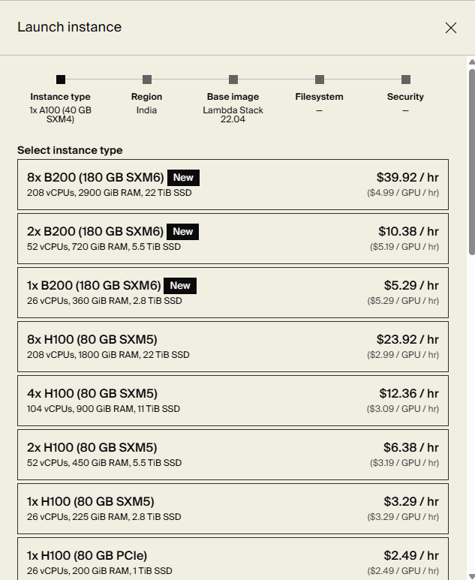

- Then select the region(country) that you want to host your instance.
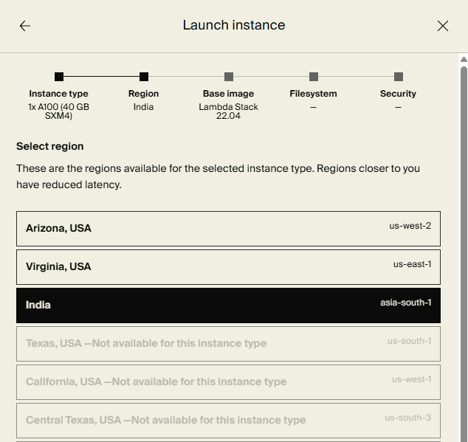

- Select the Ubuntu 22.04.05 LTS image
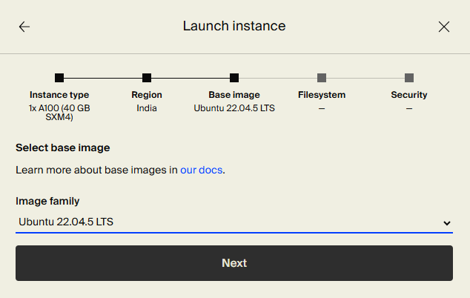
- Then create a filesystem in the same region as the instance or use an existing filesystem to attach to the selected instance and store datasets and backup system state. The filesystem being used has a capacity of up to 8,000,000 TB
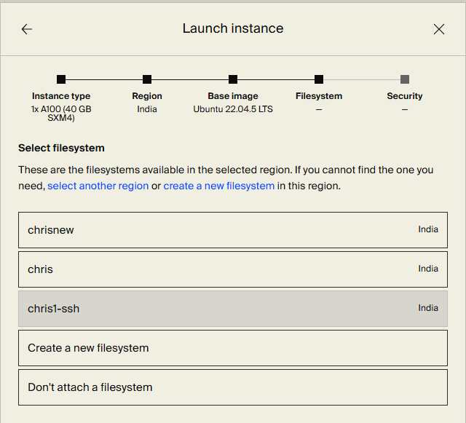
- Then create the necessary firewall rules such as SSH to be able to remotely access lambda labs securely.
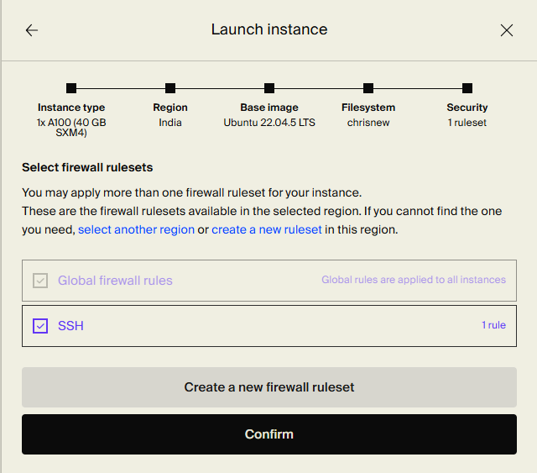
When creating a firewall ruleset, name your firewall ruleset and select the region your instance is being hosted at.
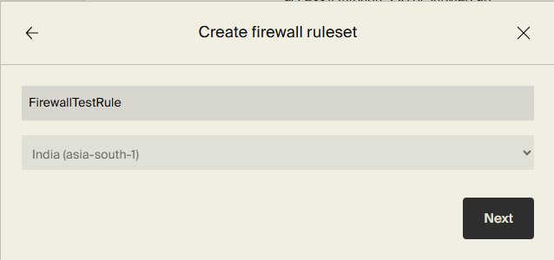
Then select “Add rule” to add the firewall rule
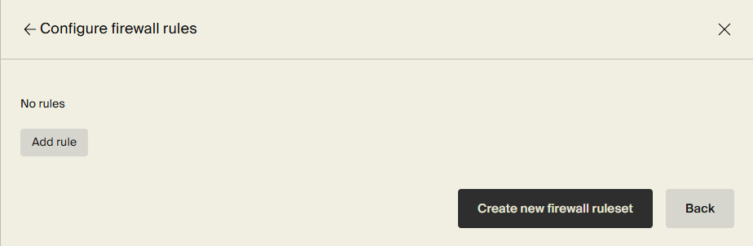
Then configure the “type”, “protocol”, “port range”, “source IP address”
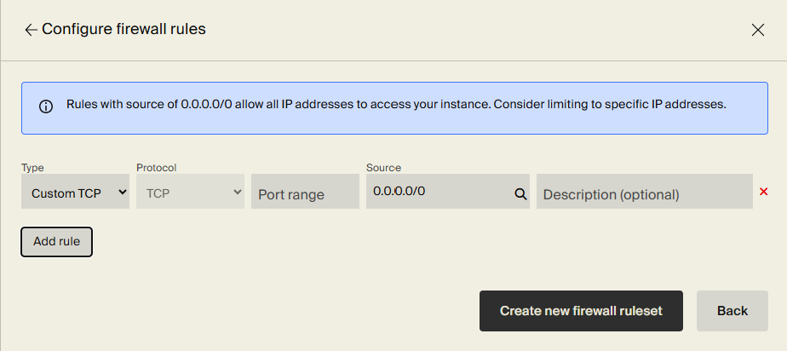

Step 6: Run the Chatbot Applications (Using Lambda Labs)
- First change directory to the folder where the SSH private key was stored e.g. Downloads

cd (directory where SSH private key is stored)

- Once directory has been set, then execute the command to SSH into the lambda instance

ssh -i /path/to/your/private_key.pem ubuntu@<instance-ip>

- Then create a bash script file to automate the installation of dependencies and deployment of the AI inference server.

nano (name of script).sh

- Then make the bash script file just created and change permissions to make the file executable.

chmod +x (name of script).sh

- Then execute the file executable and install related dependencies
./ (name of script).sh

- If you are running outdated kernels and daemon libraries, restart the libraries
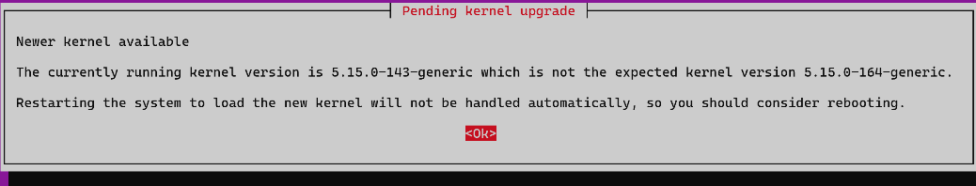
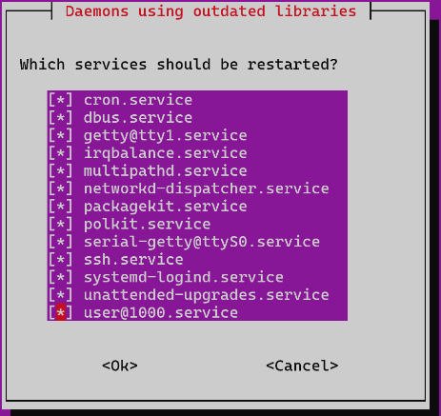
- After installing the required dependencies, start the inference server
cd ~/ socgpt_server
source venv/bin/activate
uvicorn inference_server:app --host 127.0.0.1 --port 8000

- Then in a new terminal, SSH tunnel from your local machine and forward port into the lambda labs instance
ssh -i /path/to/lambda_key.pem -L 8000:localhost:8000 ubuntu@<lambda-ip>

- To run streamlit application on front end locally, open a new terminal on your local machine
- Change directory/drive to where your local file is stored:

cd (Directory) or (Drive name )

- Activate local virtual environment:

venv\Scripts\activate

- Install Streamlit and requests:

pip install streamlit requests

- Run streamlit:

streamlit run ui/app.py

Post-installation Checklist
After setup:
- Open the chatbot in your browser
- Type a message like "Hello" to confirm it's working
- Upload a file (e.g., PDF or image)
- Check the log folders for saved chatbot sessions

Troubleshooting
If you encounter issues during installation, refer to the following table for guidance

Issue | Solution
Python not recognized | Make sure you selected “Add Python to PATH” during installation
pip is not recognized | Use “py -m pip” instead of “pip”
streamlit not found | Run ‘pip install streamlit’ in Command Prompt or Terminal
App doesn't open in browser | Go to http://localhost:8501 manually

Support

If you require further assistance, please contact our team via email. Support is available 24/7 to assist with any issues you may encounter.

Ryan Ashwin s/o Ashraf Ali: 23021484@myrp.edu.sg
Christopher Shiven Lee Jian Fu: 23000465@myrp.edu.sg
Hare: 23018454@myrp.edu.sg

